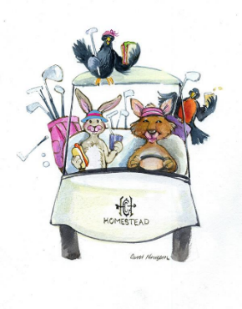HOMESTEAD WOMEN’S GOLF ASSOCIATION 18 HOLE LEAGUE
APPLICATION FOR MEMBERSHIP 2026

The Homestead Women’s 18 Hole Golf League invites golfers to join us on Thursday mornings from mid-April to mid-October. Applicant must be 18 years old, have a general knowledge of playing golf, golf etiquette, and the USGA Rules of Golf. Applicant must have current GHIN number and handicap index of 43 or lower. Our dues include membership in the Colorado Golf Association, Hole in One Pot, maintenance of your handicap, and weekly play day prize credits in the Homestead Pro Shop.
Membership fees are a one time, non-refundable fee due when membership is approved or renewed at any time during the playing season.
MAIL APPLICATION TO NANCY CALAHAN, TREASURER
8448 W. UNION AVENUE, #27, LITTLETON, CO 80123
OR email to: treas.hwga18@gmail.com

Renewing Member fees: $140/00
New Member Fees: $145.00
Write check to: HWGA18
ZELLE to treas.hwga18@gmail.com

Name:________________________________________________________________________________

Ghin Number:_______________________________Handicap Index:_________________________

Address: _____________________________________________________________________________

City: ___________________ ______________________________Zip_____________________________

Cell Phone:_________________________________________________________

Email: (Required): ______________________________________________________________________

Birthday: _______________MO/DD (new members)

How did you hear about our club? At Homestead? _____ Newspaper? _____ From a friend? _____

